**DAILY ONLINE ACTIVITIES SUMMARY**

|  |  |  |  |  |  |  |  |  |
| --- | --- | --- | --- | --- | --- | --- | --- | --- |
| **Date:** | **19-6-2020** | | | | | **Name:** | **Poojashree T** | |
| **Sem & Sec** | **8th sem B sec** | | | | | **USN:** | **4al16cs064** | |
| **Online Test Summary** | | | | | | | | |
| **Subject** | | **BDA** | | | | | | |
| **Max. Marks** | | **30** | | **Score** | | | **18** | |
| **Certification Course Summary** | | | | | | | | |
| **Course** | **Introduction to R language tutorial** | | | | | | | |
| **Certificate Provider** | | | **Great learning academy** | | **Duration** | | | **3.0hr** |
| **Coding Challenges** | | | | | | | | |
| **Problem Statement:** **1**. **to read the number and compute the series.**  **2. to count the number in th series.**  **3. to check whether number is palindrome or not.**  **4. to find the number between 0 and 50 which are not divisible by 2 and 3.**  **5.micro and array update**  Top of Form | | | | | | | | |
| **Status:completed** | | | | | | | | |
| **Uploaded the report in Github** | | | | | **yes** | | | |
| **If yes Repository name** | | | | | **Poojatgowda** | | | |
| **Uploaded the report in slack** | | | | | **yes** | | | |

**Online test**

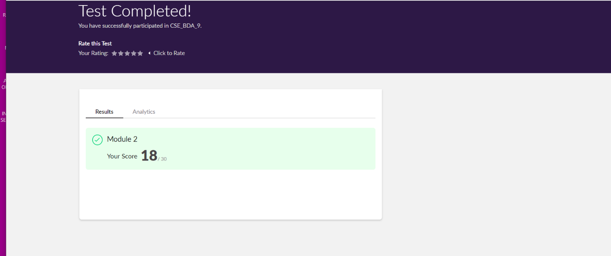

**Certification course**

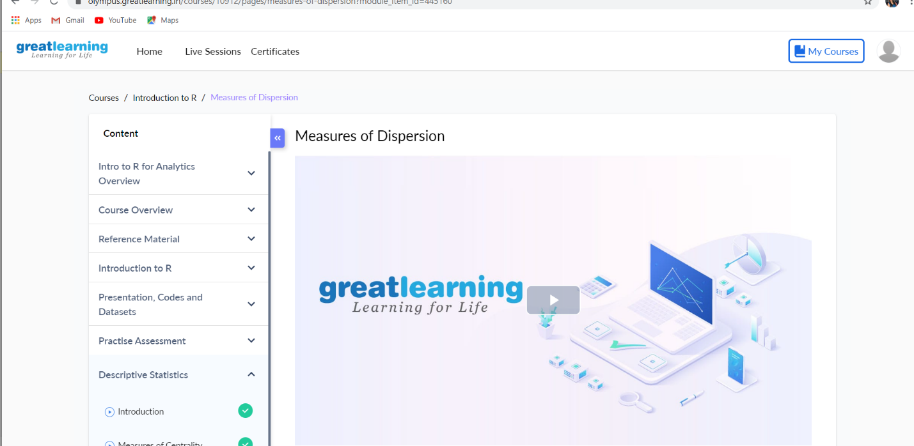

Coding

|  |  |
| --- | --- |
|  |  |

**Second Example: Sum of two numbers using Scanner**

The scanner allows us to capture the user input so that we can get the values of both the numbers from user. The program then calculates the sum and displays it.

import java.util.Scanner;

public class AddTwoNumbers2 {

public static void main(String[] args) {

int num1, num2, sum;

Scanner sc = new Scanner(System.in);

System.out.println("Enter First Number: ");

num1 = sc.nextInt();

System.out.println("Enter Second Number: ");

num2 = sc.nextInt();

sc.close();

sum = num1 + num2;

System.out.println("Sum of these numbers: "+sum);

}

}

Output:

Enter First Number:

121

Enter Second Number:

19

Sum of these numbers: 140